 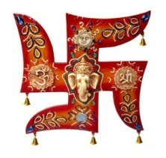 YOUR TRAVEL ADVISER!!!!!!
……………………………………………………………………………………………………………………………………………………………………………………………………
WELCOME TO DOOARS
The Dooars belonged to the Kamata Kingdom under the Koch dynasty; and taking advantage of the weakness of the Koch kingdom in subsequent times, Bhutan took possession of the Dooars. This region was controlled by the kingdom of Bhutan when the British annexed it in 1865 after the Bhutan War under the command of Captain Hedayat Ali. The area was divided into two parts: the eastern part was merged with Goalpara district in Assam and the western part was turned into a new district named Western Dooars. Again in the year 1869, the name was changed to Jalpaiguri District. After the end of the British rule in India in 1947, the Dooars acceded into the dominion of India and it merged with the Union of India shortly afterwards in 1949.
The Dooars is a large region and is dotted with many towns and cities. The largest city in the whole region stretching from the Darjeeling foothills to the Arunachal Pradeshfoothills is Siliguri. This northern Bengal city is well connected with the rest of country by road, air and railway and is the business hub of the region.
The other major cities are Kokrajhar, Bongaigaon, Goalpara, Barpeta and Dhubri in Assam. Cooch Behar, Alipurduar, Jalpaiguri, Dhupguri, Malbazar, Mainaguri and Birpara are the major cities of the Dooars in West Bengal, and Kishanganj in Bihar. Also, the commercial capital of Bhutan, Phuentsholing, near Jaigaon, can be considered a part of this region.
The beauty of the region lies not only in its tea gardens but also in the dense jungles that make up the countryside. Many wildlife sanctuaries and national park like Manas National Park in Assam, Jaldapara National Park, Buxa National Park, Gorumara National Park,Chapramari Wildlife Reserve and the Mahananda Wildlife Sanctuary in West Bengal are located in this region.
A number of rare endangered species of animals like tiger, rhinoceros and elephant make their habitat in the forests of the Dooars. Other animals includes different types of deer, bison, birds and reptiles. A railway line runs through the tea gardens and the various protected areas and a number of elephants have been killed in collisions with trains.
DAY 01 :-ARRIVAL AT NJP/BAGDOGRA & TRANSFER TO SAMSING
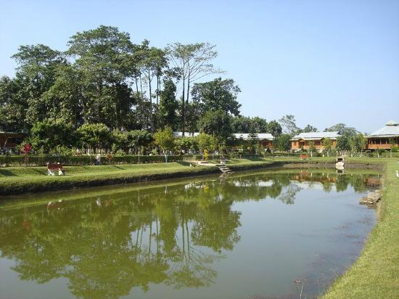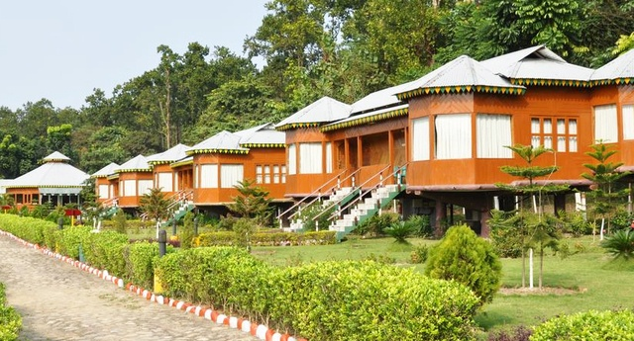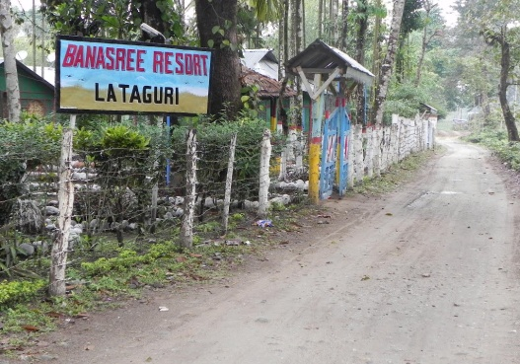

Arrival at NJP/Bagdogra & drive to Mongpong(30Kms.) a quiet place on the bank of river Tista. The forest rest house at Mongpong offers a panoramic view of Mahanda wild Life Sanctuary. Enjoy tea at Mongpong watching colourful birds. A refreshing drive through tea gardens and forests takes you to samsing (50 Kms.from mongpong). Check-in at Samsing forest rest House. Stroll around the short hilly trails near the bungalow.
Overnight halt : Samsing
DAY 02:- SAMSING - LATAGURI (38 KMS / 1 HR)
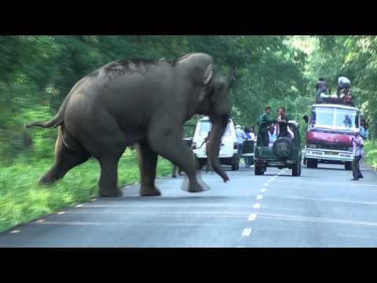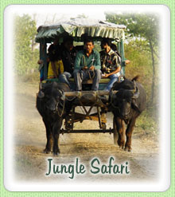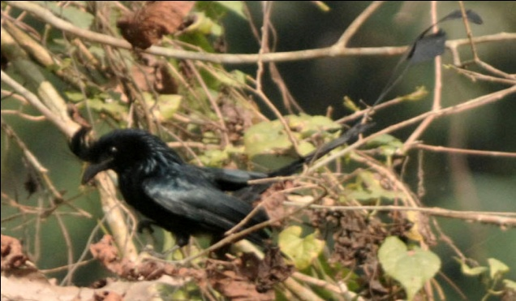
After breakfast drive to Lataguri (38 Kms. From Samsing ). The place is adjacent to the gorumara National Park. Visit to the Gorumara National Park in the afternoon for wild life viewing.

Overnight halt : Lataguri
DAY 03 :- LATAGURI – MURTI (12 KMS / 30 MINS)
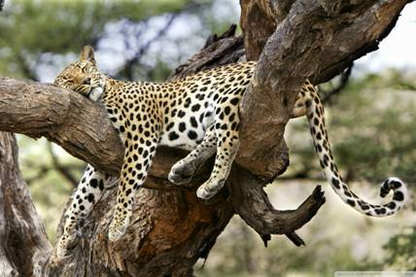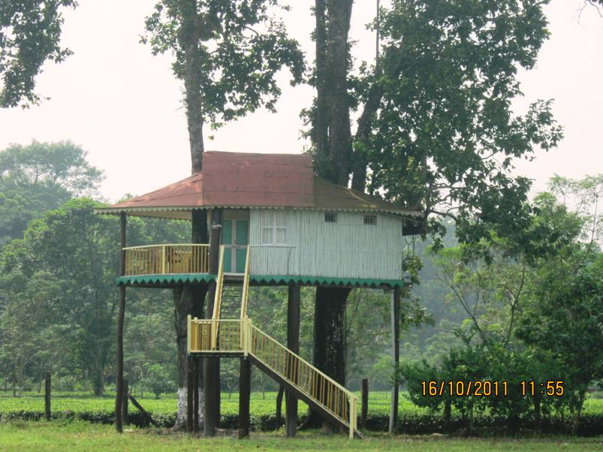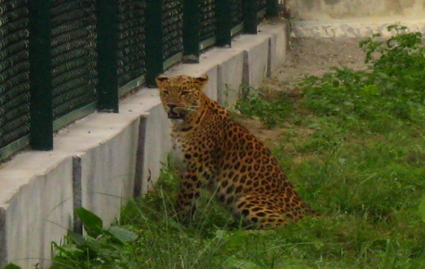
Drive to Murti (12 Kms.) The forest Rest House beside Murti River is One of the most luxurious forest rest houses in North Bengal. Enjoy quiet and leisure hours through out the day. Take a short trip to Chappramari Forest in the afternoon for wild life viewing.

Overnight halt: Murti
DAY 04:- LOWER HILL STATION EXCURSION
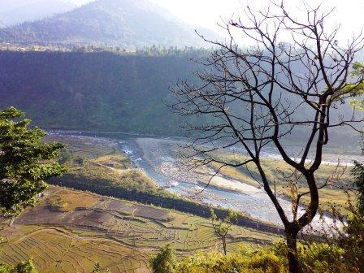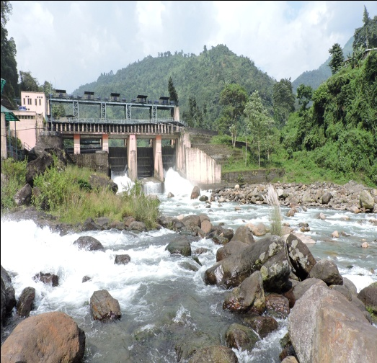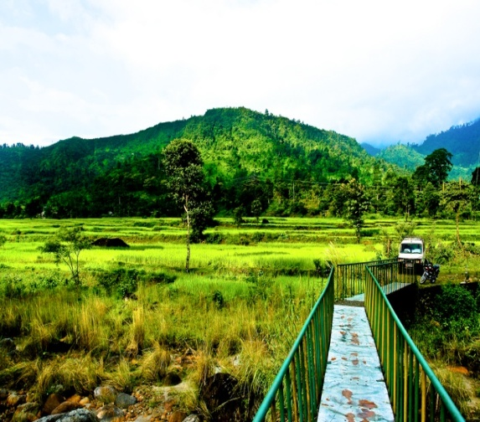
After breakfast drive to Jaldhaka, Jhalong and Bindu on Bhutan border (50 Kms.). All the places are lesser-known-Small –Lower –hill-Station but they offer an unimaginable landscape and peace, the true essence of Dooars. Back to murti in the Evening.
Overnight halt Murti

DAY 05:- MURTI – JALDAPARA (60 KMS / 2HR)
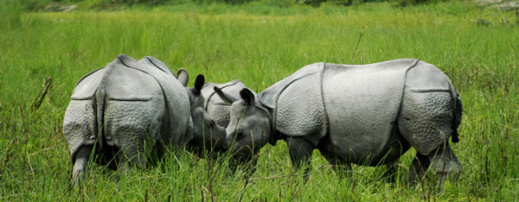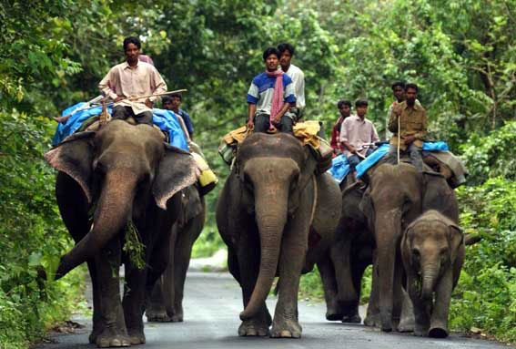
Drive to Jaldapara Wild Life Sanctuary (60 kms. From Murti). One of the very few places in India to house the Asiatic one horn rhino.
Overnight halt : Jaldapara
DAY 06 :- JALDAPARA – RAJA BHAT KHAWA (80KMS. / 2 ½ HRS)
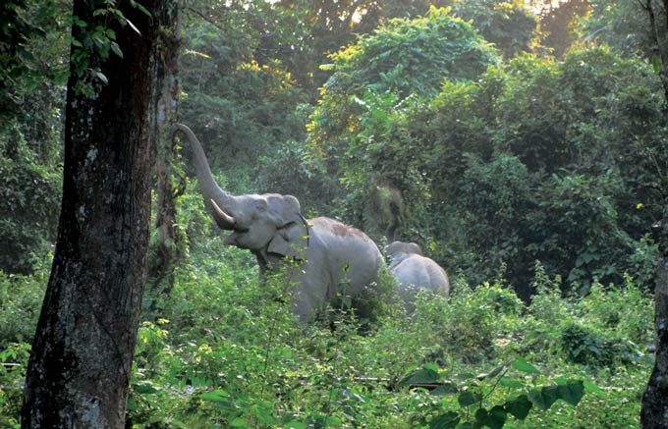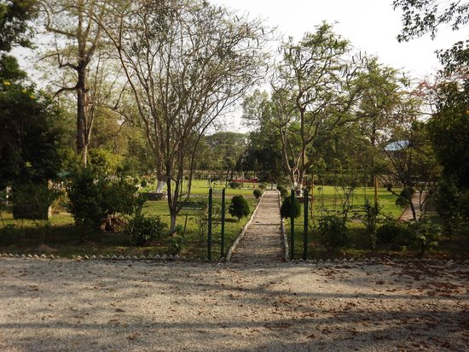
Elephant ride around forests and grasslands in the morning. Take a short drive to Phuentsholing in Bhutan. Drive to Rajabhatkhawa in Buxa Tiger reserve (80kms. From Jaldapara) in the evening.
Overnight halt : Raja Bhat Khawa
DAY 07 :- EXCURSION TO BUXA TIGER RESERVE
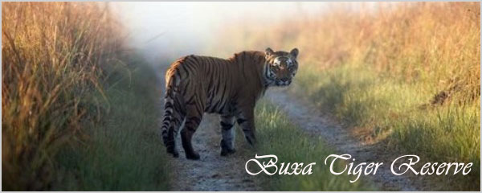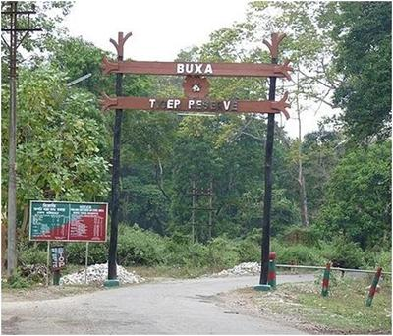
Move around Buxa Tiger Reserve recommended trip to Jayanti and Bhutan Ghat.
Overnight halt : Rajabhatkhawa

DAY 08 : RAJA BHAT KHAWA – NJP / BAGDOGRA
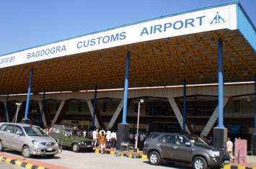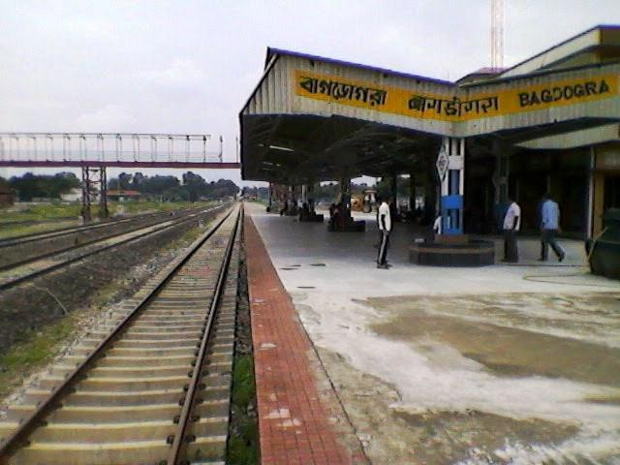
Drive back to NJP /Bagdogra the train passes through the heart of dooars and gives feeling of fulfillment of an unforgettable trip.

IMPORTANT INFO:-
The Elephant Safari and Jeep Safari is booked on the spot and is subject to availability of Elephant by forest Department of Government of West Bengal and Stipulated number of entries respectively. Incase safari could not be arranged we will provide alternate safari. The forest remains closed on Thursday.
Please advise any specific dietary requirements at the time of booking.
- Passport Name, Number,Expiry and country is required at the time of booking for International guests.
- Carry all your documents and money.
INCLUSION
- 3 NIGHTS ACCOMODATION IN 5 STAR,4 STAR, 3 STAR, DELUX & STANDARD HOTELS
- TRANSFER ALL IN PRIVATE IN 4 SEATER (WAGONR/SANTRO),7 SEATER (INNOVA /XYLO), 8 SEATER (BOLERO/TAVERA/SCORPIO/TATA SUMO)
- SIGHT SEEN AS PER ITINERARY
- DRIVER CUM GUIDE
- PICK UP AND DROP FROM BAGDOGRA AIRPORT(IXB) / NEW JALPAIGURI RAILWAY STATION(NJP)
- FOOD AS PER CP(BREAKFAST ONLY)
- VEHICLE WILL BE PROVIDEDPOINT TO POINT AND NOT AT DISPOSAL
EXCLUSIONS
- Extras of personal nature such as personal tips, laundry charges, additional tour charges.
- Does not include any Lunch, Evening Tea/snacks & dinner
- Insurance, Medical & Emergency rescue costs.
- Does not include Hard DRINKS OR liquor or mineral water or soft drinks/juices.
- Does not include Entrance Fees at Monasteries / Monuments / Museums etc.
- Does not include specialized Guide
- AIR FARE / TRAIN FARE
- ANY OTHER ITEMS NOT MENTIONED IN COST INCLUDES
HOW TO BOOK
Just pay 25 % of the package cost inclusive of taxes and full amount of the airlines cost. You will get a booking confirmation voucher within 240 minutes of the payment receipt and your booking status will be "BOOKING HOLD- CONFIRMED"
- Please do not forget to send one email to rstravels86@gmail.com
post payment mentioning your reference number. If you do not get voucher on-time you may call us at +91-8768841510

BANK ACCOUNT DETAILS

ACCOUNT HOLDER NAME :- R S TRAVELS
BANK NAME:-UNION BANK OF INDIA
ACCOUNT NO :- 702101010050095
IFS CODE :-UBIN0570214
ACCOUNT TYPE :- CURRENT A/C
BRANCH NAME :- JAIGAON

ACCOUNT HOLDER NAME :- R S TRAVELS
BANK NAME:-STATE BANK OF INDIA
ACCOUNT NO :- 35081943112
IFS CODE :-SBIN0006278
ACCOUNT TYPE :- CURRENT A/C
BRANCH NAME :- JAIGAON
PAYMENTS TERM

- 25 % at the time of booking and balance 10 days prior travel date.
- No booking are guaranteed without advance payment and rates are subject to availability.

CANCELLATION POLICY

- Less than 7 days prior to Date of Travel: 100% of the package cost as cancellation charge.
- 7-15 days prior to Date of Travel: 75% of the package cost as cancellation charge.
- 16-30 days prior to Date of Travel: 50 % of package cost as cancellation charge.
- More than 30 days: Full refund of package cost excluding processing fees.
TERMS AND CONDITIONS

- R.S travels reserves the right to re- arrange itinerary to suit hotel availability without changing the hotel number of days in each destination and without compromising any services.
- The vehicle used is Ac or Non Ac and is available for point to point services only and is not at disposal. Clients are requested to follow the itinerary.

CHILD POLICY

- Children above 10 + years will be charged 100 % as per adult rate.
- Children of age 5 to 10 years will be charged 50 % of adult.
- Children below 5 years as a complimentary

